© Robert Stuart 2015
20 Ships, Not 23: Ozawa’s Score, 5-6 April 1942

Introduction

It is well known that Vice Admiral Ozawa Jisaburo led a successful raid by his Malaya Force into the Bay of Bengal in early April 1942, concurrent with the foray into the Indian Ocean of Vice Admiral Nagumo Chūichi’s Kido Butai. As shown in Map 1, these two raids were the main prongs of Operation C, an operation which has not been adequately studied in any work published to date. Among the numerous errors often appearing in such accounts as have made it into print is the number of merchant ships sunk by Ozawa. It is usually put out that on 5 and 6 April Ozawa sank 23 merchantmen of 112,312 tons. The purpose of this article is to demonstrate that in fact Ozawa’s score was 20 ships of about 93,247 tons.

Note: Local time (Zone F, GMT+6) is used in this article, except that Map 2 uses Japan Standard Time (JST, GMT+9), and distances are in nautical miles.

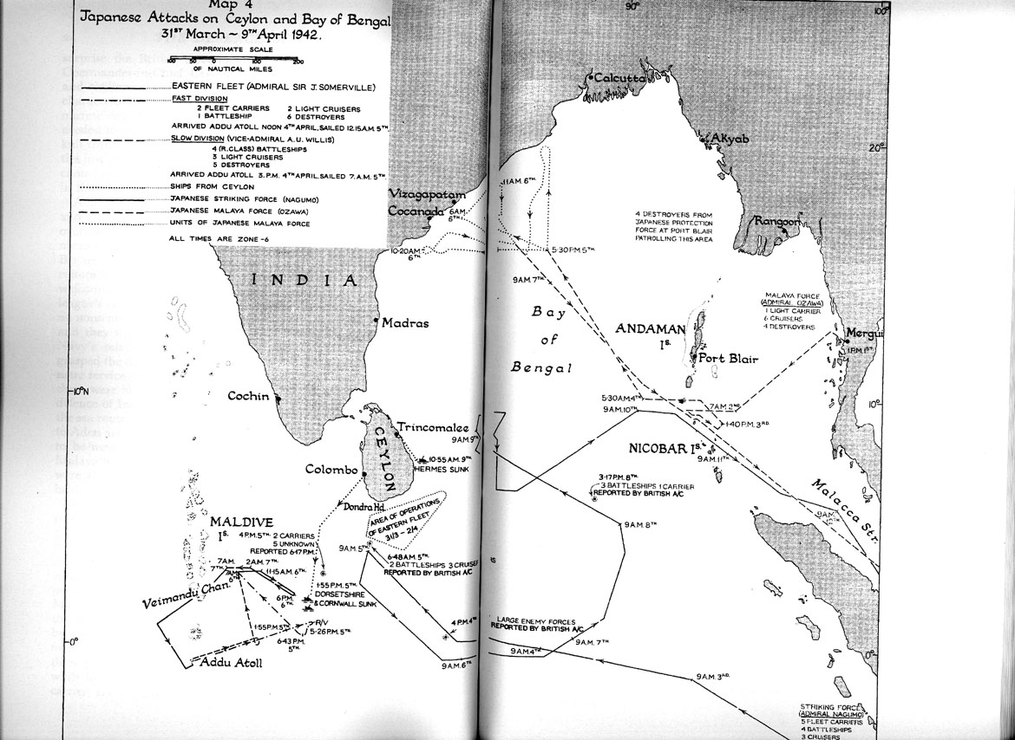

Map 1 – From S. W. Roskill, War at Sea 1939-1945, Volume II, The Period of Balance, HMSO, 1956
(Can be accessed and enlarged at http://www.ibiblio.org/hyperwar/UN/UK/UK-RN-II/maps/map4.jpg)
Deployment

As is well known, Ozawa’s force was centred on the light carrier Ryujo, which was equipped with 29 aircraft – 12 obsolete A5M4 Type 96 fighters (Allied codename Claude) and 17 B5N Type 97 (Kate) torpedo bombers. Of the Type 97s, at least four were the newer B5N2 model, the remainder being B5N1s, the underpowered original model.¹ Ozawa’s flagship was the heavy cruiser Chokai, which was accompanied by all four Mogami class heavy cruisers, Mogami, Mikuma, Kumano and Suzuya. The five heavy cruisers were all fast and powerful ships, carrying ten 8-inch guns apiece. There was also one light cruiser, Yura, and four destroyers. Initially the destroyers were DesDiv11’s (Destroyer Division 11’s) Fubuki, Shirayuki, Hatsuyuki and Murakuma, but on 3 April they were replaced by DesDiv20’s Amagiri, Yugiri, Asagiri and Shirakumo.²

Malaya Force assembled at Mergui in southern Burma during the last week of March 1942. Ozawa led it out in to the Bay of Bengal at 1100 on 1 April. He loitered just east of the Ten Degree Channel, which separates the Andaman and Nicobar islands, from 2 to 3 April. It has been suggested that he was marking time in order to synchronize his movements with Nagumo’s, which seems plausible enough, but he may simply have been waiting for DesDiv20 to arrive and relieve DesDiv11.³ In any case, Ozawa passed through the Ten Degree Channel during the night of 3 to 4 April and at about dawn on 4 April shaped course to the northwest, toward India’s northeastern coast.

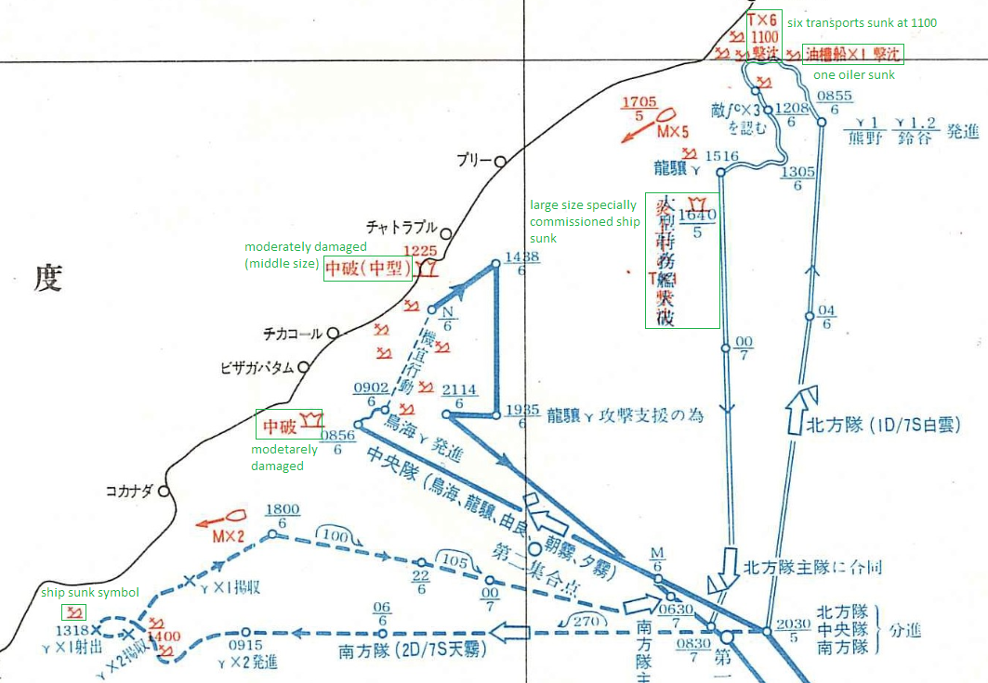

Map 2 – From Senshi Sosho, Volume 26, via genie854⁴
(A larger version can be accessed at http://propnturret.com/tully/viewtopic.php?f=4&t=2667)
5 April

Ryujo had an active and successful day on 5 April.⁵ At first light, from a position 260 miles west of the Andamans, Ryujo launched three Type 97s to search ahead 260 miles, but they did not sight anything. However, following a report from a cruiser floatplane of a convoy of about 10 ships, Ryujo launched ten Type 97s in five pairs between 1133 and 1210, sending them out on search-and-bomb missions to the northwest. The aircraft were armed with 60 kg bombs, apparently with just four apiece. Three of the five pairs found targets.⁶ From Allied records it is clear who their victims were:

Harpasa. A British cargo vessel of 5,082 tons, Harpasa sailed from Calcutta on 1 April,⁷ bound for Mombasa. She reportedly joined up with a group of seven other ships at the mouth of the Hooghly on the morning of 4 April but soon feel astern. At 1435 on the 5th, the ship sighted two Japanese aircraft. The planes’ first pass scored no hits but during their second run they put a number of bombs, reportedly five but probably fewer than that, in to No. 5 hold. A fire broke out and the ship began to settle. Harpasa was abandoned by 1600 and an hour later an explosion destroyed the after part of the ship. Allied sources say that the ship went down at 19.19N, 85.46E, which is about 25 miles off the coast. Six members of the crew were killed, the 33 survivors being picked up by Taksang. On Map 2, Harpasa is the “large size specially commissioned ship” shown as having been sunk at 1640 JST (1340 local). The attacking aircraft were very probably the pair of Type 97s from Ryujo led by Lt. Yamagami Masataka, since it was these aircraft which, at 1405 (1705 JST), sighted the five southbound ships marked “Mx5” on Map 2.⁸

Dardanus. A British ship of 7823 tons, Dardanus left Sandbanks, at the mouth of the Hooghly, on 3 April in company with the Greek Point Clear and the Norwegian Hermod. The three ships remained in company until the evening of 4 April, when they dispersed. Bound for Colombo in ballast, Dardanus proceeded independently, along the coast. It was attacked south of Cocanada, probably at 16.38N, 82.30E, by two Type 97s. It was hit in the engine room by a 60 kg bomb, disabling it, and 10 minutes later the same two aircraft attacked again and another bomb holed the ship’s side, flooding the engine

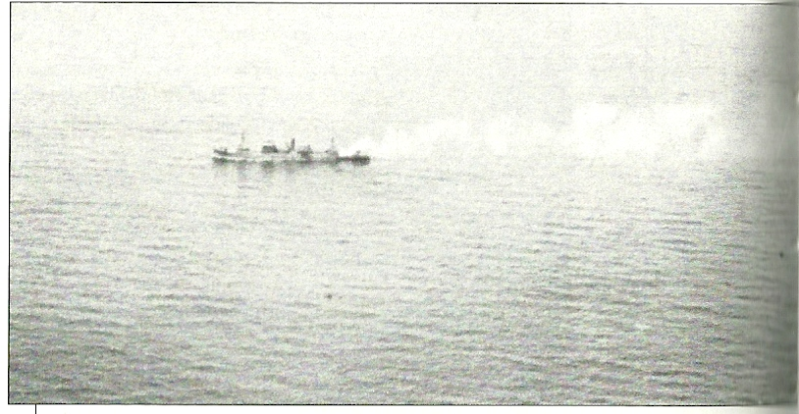
Harpasa on fire after being attacked by B5Ns from Ryujo on 5 April 1942¹⁰
room and No. 6 hold. Dead in the water but apparently in no immediate danger of sinking and having suffered no casualties, at 1900 Dardanus was taken in tow toward Madras by Gandara (UK, 5281 tons). The Type 97s were possibly the pair led by PO1c Yamaguchi Shuichi. He reported that at 1432 they spotted two merchant ships headed south, one of 7,000 tons and one of 10,000 tons, and bombed the latter, which was set on fire and stopped.⁹

Point Clear. A US-built Greek ship of 4839 tons, Point Clear was bound for Suez with 5138 tons of “R.E.” (Royal Engineers, presumably) stores and an unspecified tonnage of “commercial cargo”. It left Calcutta on 1 April and on 3 April sailed from Sandheads in company with Dardanus and Hermod, separating from them on 4 April as already noted. Little has been recorded of the 5 April attack on Point Clear, which possibly was made by the pair of Type 97s led by Lt (JG) Sato Ryozo, who reported attacking a 7,500 ton ship at 1355, other than that the ship was damaged and put in to Vizagapatam. We can assume that the damage was probably not too serious, however, since Point Clear departed from Vizagapatam on 5 May and got back to work. It survived the war and was scrapped in 1954. So far as the author has been able to determine, there was only one casualty, radio officer Robert Francis Brooks, a 20 year old Canadian who was apparently the first fatal casualty of Ozawa’s raid.¹¹

None of the six attacking aircraft sustained any damage and for the expenditure of just twenty 60 kg bombs they sank one ship, disabled another and damaged a third.¹²

One more 5 April event remains to be noted. At 1730, at approximately 16N, 86.40E, Ozawa divided his force into the following groups:

Northern Group: Kumano, Suzuya and Shirakumo, under Rear Admiral Kurita Takeo

Centre Group: Ryujo, Chokai, Yura, Yugiri and Asagiri, under Ozawa aboard Chokai

Southern Group: Mogami, Mikuma and Amagiri, under Mikuma’s Captain Sakiyama Shakao

As depicted in Map 2, the three groups headed for widely separated points off the Indian coast. In fact, the northern and southern groups were to be almost 400 miles from each other, come the morrow.

Northern Group

Kumano, Suzuya, and Shirakumo sank seven ships in just over three hours. Their first victim was the 5,381 ton Norwegian tanker Elsa, which was in route from Madras to Calcutta with a cargo of 7000 tons of kerosene. The first mate sighted the three warships at about 0600. He immediately notified the captain, who came to the bridge, and when one of the warships signalled for the ship's name, the captain gave it, thinking the ships were British. The warships then opened fire. The crew ran to the lifeboats, launching the port and starboard boats as well as the gig while the shells were raining around them. One crew member was killed and several of the 29 survivors were wounded. The ship was set ablaze and continued to burn until she finally went down late that afternoon.¹³

The Northern Group’s next successes were heralded at 0734 by a signal from one of its targets:

RRRR MALDA 19º 45’ N. 86º 27’ E. ENEMY BATTLESHIPS IN SIGHT. COURSE 249º 0134 G.M.T./6.

This was the surface raider (“RRRR”) report from Malda, commanded by Captain H.M. Edmondson, who evidently mistook the cruisers for battleships. Edmondson was the Acting Commodore of an unescorted convoy of six ships, all of which were sunk by gunfire from the three Japanese ships:

Malda, UK flagged, 9066 tons, bound for Colombo. Twenty-five killed, 154 survivors. Malda was to be the largest ship sunk by Ozawa’s force.

Autolycus, UK, 7718 tons, bound for Madras. At least 11 of the 100 souls aboard her were killed.

Indora, UK, 6622 tons, bound for Mauritius. There were 81 survivors but two Indian crewmen perished.

Exmoor, US, 4986 tons, bound for Colombo with 3800 tons of manganese ore and jute. All hands survived.

Silksworth, UK, 4921 tons. The eight officers and 49 Chinese crewmen all survived.

Shinkuang, UK, 2441 tons. Three crew members were killed.

The convoy had sailed from Sandheads at 1800 on 5 April. It proceeded on a southwesterly course at 8 knots until midnight, when course was altered to about SSW. At about 0700 on 6 April an H6K Type 97 (Mavis) flying boat from Port Blair approached from forward of the port beam, reportedly flying in at about 150 ft. Autolycus opened fire and tracer rounds were seen to hit the aircraft, which disappeared to the north. Directly afterward the convoy was approached by a Japanese biplane, presumably an E8N Type 95 (Dave) floatplane from Kumano or Suzuya. After passing over the convoy it flew to the north and then returned, taking a position astern of the convoy but out of gun range. A few minutes later the Japanese warships came up from astern and rapidly overhauled the convoy, opening fire at about 0800 at a range of three miles. Edmondson ordered the convoy to scatter, but there was no hope of escape. Autolycus was the first to be hit and sank at about 0845. Exmoor, the last to be attacked, sank at 0915.¹⁴ On Map 2, the annotation “six transports sunk at 1100 [JST]” indicates the position where this convoy was attacked.

The cost to the Northern Group of sinking these seven ships was 523 8-inch and 450 5-inch shells. It sustained no damage or casualties, except that when one of Kumano’s floatplanes was preparing to alight near the cruiser, it was jumped and damaged by a Mohawk from 5 Squadron RAF flown by Flt Lt Keith MacEwan, RNZAF, who fired about 600 rounds at it.¹⁵

Centre Group

Ozawa’s Centre Group, under his own command, sank eight ships on 6 April. Most of these ships had sailed from Sandheads at 1800 on 4 April as part of a group of 13 ships led by Taksang, but by dawn on 5 April six had lost contact with the convoy. At 1600 on the 5th Taksang left the convoy and went to the aid of Harpasa, which was then 10-15 miles to eastward. Ganges took over responsibility for the convoy, but it dispersed at 1900 that day, in accordance with the sailing orders. Thus the ships the Centre Group encountered on 6 April were by then all sailing independently, but some were in close proximity.¹⁶

It is very probable that Ozawa detached Yura and Yugiri to operate inshore. This may have happened as early as 0602 (0902 JST on Map 2), but possibly it was after 0630, when an unidentified Allied ship or aircraft reported “One aircraft carrier, one battleship [Chokai], two destroyers, one light cruiser” steering 035 degrees at 17.40N, 83.50E, which is about 20 miles east of Vizagapatam. (This report may well have been based on a sighting by an old Wapiti biplane from 6 Coast Defence Flight, Indian Air Force, which was patrolling off Vizagapatam that morning.)¹⁷

Japanese records indicate that Yura, accompanied by Yugiri and supposedly also by Ryujo, sank the following ships on 6 April:

a Dutch ship of about 3000 tons, at 0655 (local time)
a British ship of about 6000 tons, at 0745
a Dutch ship of about 3000 tons, at 0845¹⁸

There can be little doubt about the identity of the two Dutch ships. Only three Dutch ships were sunk on 6 April and one of them, Van der Capellen, was sunk by air attack, as noted below, so the two sunk by Yura and her consort(s) must be:

Banjoewangi, Dutch, 1279 tons, bound for Karachi. Lacroix and Wells identify her as being sunk by Yura and Yugiri at 0655, and she is reported to have sunk at 17.35N, 83.45E. Thirteen of Banjoewangi’s crew were lost. ¹⁹

Batavia, Dutch, 1279 tons, sister ship of Banjoewangi and likewise bound for Karachi. Lacroix and Wells identify her as being sunk by Yura and Yugiri at 0845, and she is reported to have sunk at 18.12N, 84.21E. Four of Batavia’s crew were lost.²⁰

The British ship was Taksang, a vessel of 3471 tons. Lacroix and Wells identify her as being sunk by Yura and Yugiri at 0745, and she is reported to have sunk at 17.52N, 83.40E. Fifteen of those aboard her were killed, but 107 survived, evidently including a number of survivors from Harpasa. ²¹

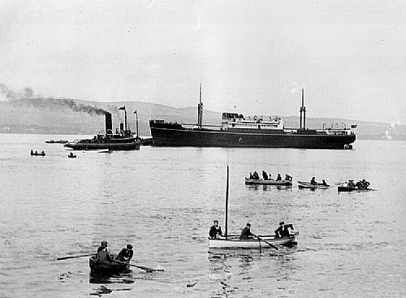

Taksang²²
The positions given above are from Allied sources. The positions for Banjoewangi and Taksang correspond well with the positions of the more southerly two of the three ships shown on Map 2 as having been sunk inshore by the Centre Group between 0902 and “N” (Noon) JST, which would be 0602-0900 local time. Batavia’s position, as given above, is further to the northeast than the position shown on Map 2 for the third ship sunk inshore. Discrepancies in Allied records for the positions at which ships were attacked or sunk are to be expected, given the preoccupation of the crews with their sheer survival and the probable loss of their charts and logs. There is however little doubt that Batavia was the third ship sunk inshore.

It is claimed in volume two of Bloody Shambles that survivors from Taksang “reported being shelled and sunk by an aircraft carrier”, however a major flaw of this book is its complete lack of source citations, so we have no real idea where this statement came from. Bloody Shambles and Wings of the Dawning, apparently citing the same 1945 source, both refer to a Wapiti from 6 CD Flight seeing flashes to the northeast when about 30 miles off Vizagapatam, heading in that direction and then sighting “an aircraft carrier, several cruisers and destroyers belching fire at a merchant vessel”. No time or position is given, but since Taksang was probably only about 10 miles offshore, this was probably another ship – possibly Ganges (see below), which was sunk about 50 miles northeast of Vizagapatam.²³

The following three ships were sunk by the Centre Group’s main body:

Bienville, US, 5491 tons, bound for Colombo with a cargo of 2500 tons manganese ore, 5000 tons jute gunnies, and, very unusually, 500 monkeys designated for use in polio research by the Rockefeller Foundation. According to Allied accounts, lookouts sighted two aircraft approaching the ship at 0618. They dropped four bombs, of which one struck No. 2 hatch and set the cargo afire, one was a near miss and two missed astern. While this was going on a cruiser with an aircraft carrier astern and a destroyer on each beam closed in. At 0640 the cruiser started shooting, firing “five turret salvos at the rate of one every two or three minutes”. This description matches Chokai very well, as its main armament was in five twin turrets, and Lacroix and Wells state that Bienville was sunk by Chokai, at 0819. Nineteen of her crew of 43 died during the attack, and five more died from their wounds later.²⁴

U.S. Merchant Vessel War Casualties of World War II and The Official Chronology of the U.S. Navy in World War II say that Bienville was sunk at 17.50N, 84.50E, but this is about 40 miles east of the position at which Ganges was probably sunk, and these two sinkings were too close together in time to be that far apart. It’s also inconsistent with Map 2, which has the three ships in a roughly southwest to northeast line. It seems more likely that Bienville was attacked nearer 17.48N, 84.09E, the position given in a C-in-C East Indies signal of 8 April.²⁵ This is also the position at which Ganges is reported to have been sunk, but as there is no indication that either ship sighted the other it is more likely that Bienville was a little ways to the south.

It has been reported that Bienville was also engaged by Ryujo’s guns and that it was finished off by a torpedo from Chokai.²⁶ The author has seen nothing in Allied accounts confirming either claim, insofar as Bienville specifically is concerned, but both are perfectly plausible and should be accepted if based on reliable information from Japanese sources – as they probably are.

Ganges, UK, 6246 tons, bound for Madras with 7000 tons of general cargo. According to the detailed July 1942 report submitted by the ship’s master, Captain Vivian, Ganges was attacked twice by aircraft, first at 0700 by an unidentified single aircraft, presumably a floatplane from Chokai, which scored a near miss. At 0703 Ganges then sighted a destroyer and two bombers, undoubtedly B5Ns from Ryujo. The two bombers attacked, scoring a hit on No. 1 hatch and setting the cargo on fire. At 0710 the destroyer opened fire, and Vivian ordered abandon ship at 0712. By then the destroyer had been joined by a heavy cruiser, a light cruiser, and an aircraft carrier, all of which joined in the shelling of the helpless merchantman. The warships ceased fire and departed at 0815, and Ganges sank at 0845, according to Vivian’s report. Lacroix and Wells state that Ganges was sunk by Chokai at 0840, which is consistent with Vivian’s account, which also says that Ganges was sunk 25 miles from the coast. The position for its loss has been recorded in other sources as being 17.48N, 84.09E, which is about 28 miles from the coast. Of the 56 souls aboard, 11 were killed.²⁷

Sinkiang, UK, 2646 tons, bound for Colombo. Sinkiang was one of the 13 ships which left the mouth of the Hooghly in company at 1800 on 4 April and it was still with the group of six led by Ganges (after Taksang went to Harpasa’s rescue) which dispersed on the evening of 5 April. Lacroix and Wells state that Sinkiang was sunk by aircraft from Ryujo but there is strong evidence that while it was indeed attacked by aircraft, it was in fact sunk by Chokai. In the first place, British records show that they picked up a signal from Sinkiang at 0811 giving its position as 17.32N, 83.50E and saying that it had sighted an aircraft carrier and was being closed by a cruiser. A few minutes later, apparently at 0823, a garbled RRRR signal saying “sinking cruiser” was received from an unidentified ship, probably Sinkiang, since it gave its position as 17.32N, 83.50E. As well, the C-in-C East Indies reported on 8 April that Sinkiang was “bombed and gunned in 17.32, 82.50”.

As it happens, the radio officer on duty on Sinkiang that morning, Stanley Salt, wrote an account of its loss in 1950. He mentions a single attack by one aircraft, which dropped a bomb which fell wide. Then, he says around 0830, he picked up reports from a nearby ship that it had sighted enemy warships and then that it was being shelled, and at that point gun flashes could be seen in the distance from Sinkiang. A few minutes later “two ships took shape on the eastern horizon, a flat-top and a cruiser […] I began to tap out our plight to the listening shore station; RRR S.S. Sinkiang SIGHTED ENEMY CRUISER AND AIRCRAFT-CARRIER”. This may in fact have been the signal picked up at 0811. Salt then describes his ship being shelled and sinking. He does not suggest that the carrier, obviously Ryujo, participated in the shelling, nor does he note any additional Japanese ships arriving.²⁸

The position given for Sinkiang’s loss, 17.32, 82.50, is probably wrong. This position is southwest of the area where Bienville must have been sunk, but Sinkiang was attacked after Bienville, and after Ganges if Salt’s timings are accurate, and the Japanese ships were moving from southwest to northeast. It’s probably reasonable to suppose that Sinkiang was in fact the northeastern most of the Centre Group’s three offshore victims, i.e. the one directly below the N notation on Map 2.
⁶
Despite the uncertainty over their positions, it is evident that Bienville, Ganges and Sinkiang were sunk in rapid succession and must have been in fairly close proximity. It is also noteworthy that the survivors’ accounts for Bienville and Ganges both refer to being attacked by four Japanese ships – a cruiser, an aircraft carrier and two destroyers in the first case, and a heavy cruiser, an aircraft carrier, a light cruiser and a destroyer in the second. Salt’s radio messages and his postwar account likewise mention an aircraft carrier and a cruiser, undoubtedly Chokai, so it seems certain that Ryujo was continuously in company with Chokai from not later than 0640 until probably at least 0830, during the attacks on Bienville, Ganges and Sinkiang. We can also say that Banjoewangi, Taksang and Batavia were sunk by Yura and Yugiri in this same period, from 0655 to 0845, and at some distance away – probably between 20 and 25 miles, if the positions in Map 2 are reasonably accurate, as they likely are. It follows from this that Ryujo could not have been in company with Yura and Yugiri, and in particular that the various accounts claiming that Ryujo participated in the shelling of Taksang must be mistaken.

The Centre Group’s remaining two victims were sunk by its aircraft:

Selma City, US, 5686 tons, bound for Calcutta from Colombo with 311 tons general cargo and 150 tons case oil and lube oil. At about 0645 it was bombed by a floatplane, presumably from Chokai, probably at 17.29N, 83.32E, which is about 20 miles southeast of Vizagapatam. Fire broke out and spread rapidly as the engine room slowly flooded. At 1130 the captain ordered the ship abandoned, and shortly thereafter it was attacked by two B5Ns from Ryujo which scored a further two hits. All 29 hands survived, two of them reporting slight injuries from bomb fragments. When the crew left the vessel it was ablaze and sinking, eventually going under the following day, 7 April, at 10:45. Selma City was the only northbound ship sunk by the Centre Group.²⁹

Van der Capellen, Dutch, 2073 tons, bound for Bombay with 1170 tons general cargo. Van der Capellen suffered an engine breakdown early on 6 April and lay motionless until repairs were completed at 0700. It was spotted by an unidentified Japanese aircraft at 0900, and attacked at 0930 by two B5Ns from Ryujo, sinking on 8 April at about 18.20N, 84.18E.³⁰ On Map 2 Van der Capellen is the “moderately damaged (middle size)” ship attacked at 1225 JST (0925 local).

A ninth ship survived its encounter with the Centre Group that morning. This was Anglo-Canadian, a British ship of 5268 tons. (The author of the current article cannot help but feel a certain affinity with this ship, since he is himself Anglo-Canadian.) Northbound from Colombo, Anglo-Canadian was attacked at about 1010 by five B5Ns. Two were armed with torpedoes and three carried one 250 kg and four 60 kg bombs each. The ship’s master, chief officer and carpenter were decorated for their conduct and the attack was described in the citation as follows:

When sailing alone, the ship was attacked by Japanese aircraft with torpedoes and bombs for over two hours. She was handled with great skill by her Master and her armament was used to good effect. Although she evaded all attacks by torpedo carriers, she was hit by a bomb and set on fire. By the persistence and courage of her fire-fighting parties, well led by the Chief Officer and Carpenter, she was saved.

After this attack Anglo-Canadian put into Vizagapatam, which was nearby. The fire damage was evidently not too serious (the bomb did not actually explode), since Anglo-Canadian sailed from Vizagapatam on 11 April. It was sunk by U-143 in the Atlantic on 3 June. ³¹

Ryujo’s aircraft were also employed to raid Vizagapatam (now Vishakhapatnam) and Cocanada (Kakinada), both towns of about 40,000 people, the first ever air raids on India. Information on these raids is scarce but we know that Ryojo launched three strikes of five Type 97s each at the following times to attack these ports:

- 1143: five Type 97s armed with one 250 kg bomb and four 60 kg bombs. These aircraft attacked Vizagapatam between 1300 and 1345, according to a 7 April report by the RAF’s 224 Group.

- 1330: two Type 97s armed with one 800 kg bomb each, three armed with one 250 kg bomb and four 60 kg bombs each. This strike attacked Cocanada, probably from 1405 to 1454. Apparently one of the 250 kg bombs failed to release.

- 1655: five Type 97s armed with one 250 kg bomb and four 60 kg bombs each. This strike hit Vizagapatam, probably between 1725 and 1745, and was likely flown by the same five aircraft and crews which had made the 1300-1345 raid.

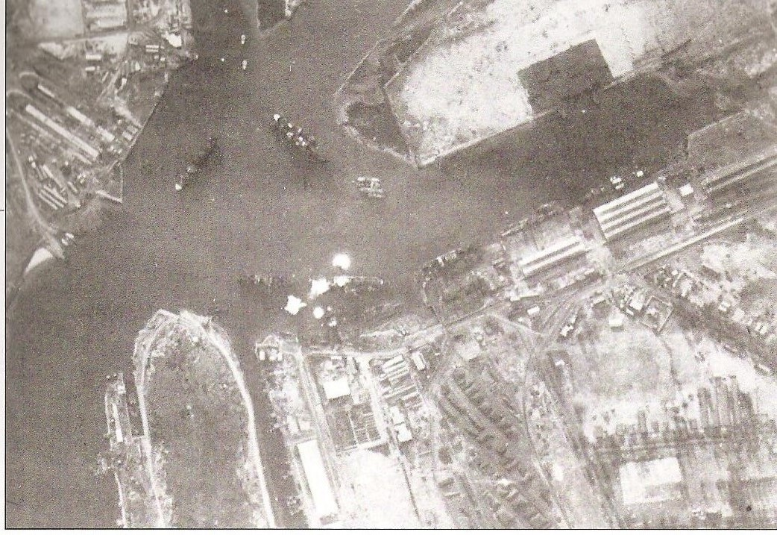

Vizagapatam under attack by B5Ns from Ryujo on 6 April 1942³²

The two raids on Vizagapatam appear to have enjoyed little success, at least in terms of damaging the ships in the harbour. A 224 Group signal of 7 April says that the bombing was accurate during both raids and that there was “Damage to ships in harbour and power house”. However, the next day the RAF theatre headquarters in New Delhi reported only that the power house and harbour workshops were damaged. More significantly, a signal sent from Royal Indian Navy (RIN) headquarters on 7 April lists the nine merchant ships in port on that date, and British ship movement records suggest that there had been no change since the previous day. A 2002 report in The Hindu says that a ship called Marine Maller was hit by a bomb which did not explode and which is now on display at the local museum. This was apparently a 250 kg bomb and the ship was probably Marion Moller, which had arrived on 5 April. This may have been the only ship hit. It was certainly not sunk, because it was torpedoed and sunk by Japanese submarine RO-113 in November 1944. Neither were any of the other eight ships present sunk on this occasion, since they are known to have sailed on later voyages, and there is no mention in the RIN war diary that any of the four small warships stationed at Vizagapatam were hit. The Commonwealth War Graves Commission names nine Indian civilian dead but no seaman, suggesting that no one died on any of the ships in the harbour and making it a fair bet that none but Marion Moller was hit.³³

Information about the raid on Cocanada is very sparse. A report in The Hindu says that two ships were damaged, but this is not confirmed. The two ships known to have possibly been in port at Cocanada are the Norwegian Dah Pu and the British Oriskany. Dah Pu arrived at Cocanada on 4 April but it sailed on 6 April at an unknown time, so it may or may not have been present during the raid. Oriskany arrived on 1 April but its date of departure is not known, so again it may or may not have been present. It is certain that neither ship was sunk, however. Da Phu was sunk in June 1943 by I-27 and Oriskany was sunk in February 1945 by a German submarine, probably U-1208. Neither the RIN War Diary nor any other
primary source indicate that any ship was damaged at Cocanada.³⁴

Southern Group

Four Allied ships were lost to Mogami, Mikuma and Amagiri. At 0750 “one enemy seaplane”, no doubt a floatplane from Mogami or Mikuma, came upon Gandara with Dardanus still under tow, about 40 miles south of the position at which the latter had been disabled. The aircraft dropped an unknown number of bombs, all of them near misses. Some 20 to 30 minutes later the three warships arrived on the scene and opened fire on the two merchantmen, which were finished off with torpedoes from Amagiri. Gandara lost 15 men, but 64 survived, as did all 78 aboard Dardanus. The authorities ashore had again been helpless to intervene when the victims sounded the alarm:

RRRR. Position 16º 00’ north 82º 20’ east, 2 battleships and cruisers coming up. Gandara, Dardanus 0220 G.M.T./6.³⁵

The Southern Group then encountered two Norwegian ships:

Dagfred, 4434 tons, bound for Madras from Calcutta in ballast. On 4 April Dagfred, which was then anchored off Sandheads, was ordered to proceed to Madras as soon as possible. Mogami, Mikuma and Amagiri intercepted Dagfred just before 0900 on 6 April, at 16.15N, 82.09E, which is about 14 miles off the coast and about 18 miles northwest of the position where they had found Dardanus and Gandara. The survivors reported that the warships signalled for them to abandon ship immediately, and the crew were in three lifeboats about 200 meters behind Dagfred when the first shots were fired. A little over 10 minutes later they could see she was about to sink. All 40 officers and crewmen survived, in spite of being strafed by two of the three aircraft, presumably floatplanes from the cruisers, which appeared on the scene. About 30 minutes after Dagred sank, her crew heard gunfire from the south. Then, “suddenly both cruisers appeared on the horizon, approaching at great speed. At that moment they were convinced they would be taken prisoners, but the warships continued on their way north.”³⁶

Hermod, 1515 tons, bound for Colombo from Calcutta. Allied accounts provide only a vague description of the position at which Hermod was attacked, i.e., that it was about 10 miles off the coast and that when the crew reached shore six hours later they apparently landed at what is now called Antervedi Pallipalem. However, the time at which it was attacked is given as 0414 GMT, which would be 1014 local and 1314 JST. Map 2 has one of the Southern Group’s victims sinking at 1318 JST, and this corresponds rather well with this information, so this is almost certainly Hermod. According to the survivors’ accounts, Hermod was sunk by shelling from the Japanese warships and sank in only eight minutes, but all 36 officers and crew escaped in three lifeboats. Two aircraft circled above the area but did not fire on the lifeboats.³⁷

The Southern Group expended a total of 404 eight-inch and five-inch shells, and three torpedoes, the latter all launched by Amagiri, apparently only at Gandara and Dardanus. The three Japanese ships sustained no damage and suffered no casualties.³⁸

Not a Clean Sweep

It is worth noting that Ozawa did not attack every Allied merchantman sailing along India’s northeast coast on 6 April. For example, the tanker British Chancellor (7085 tons) sailed from Madras for Calcutta on the same day as Elsa, 3 April, but arrived safely at Sandheads on 7 April. It appears that British Chancellor was about a knot slower than Elsa and may have been in the gap between the Northern and Centre Groups on 6 April.³⁹ A few other unidentified ships may have slipped through the net, but there can be no doubt that Ozawa positively decimated the shipping along a 400 mile length of India’s east coast, with just three small groups of ships and a handful of aircraft.
Ozawa’s Score

Figure 1 lists the 20 ships sunk by Ozawa’s Malaya Force and the three ships it is known to have damaged. While it is possible that it may have damaged additional ships, there is no chance that it sank any but the 20 ships listed here. The loss or disappearance of other ships would not have escaped the notice of the Allied authorities, who controlled and carefully documented all shipping movements. No other losses are noted in the RIN War Diary, the Commander-in-Chief East Indies War Diary or any other primary source found by the author during seven years of research, or in such reference works as British Merchant Vessels Lost or Damaged by Enemy Action or U.S. Merchant Vessel War Casualties of World War II, or on the very admirable websites convoyweb.org.uk, warsailors.com and wrecksite.eu.

SHIPS SUNK
Ship | Tonnage | Flag | Sunk By | How Sunk
Harpasa | 5082 | UK | Ryujo | Bombing
Elsa | 5381 | Norway | Northern Group | Gunfire
Malda | 9066 | UK | Northern Group | Gunfire
Autolycus | 7621 | UK | Northern Group | Gunfire
Indora | 6622 | UK | Northern Group | Gunfire
Exmoor | 4986 | US | Northern Group | Gunfire
Silksworth | 4921 | UK | Northern Group | Gunfire
Shinkuang | 2441 | UK | Northern Group | Gunfire
Banjoewangi | 1279 | Netherlands | Centre Group (Y&Y) | Gunfire
Taksang | 3471 | UK | Centre Group (Y&Y) | Gunfire
Batavia | 1279 | Netherlands | Centre Group (Y&Y) | Gunfire
Bienville | 5491 | US | Centre Group | Bombing, gunfire, torpedoing
Ganges | 6246 | UK | Centre Group | Bombing, gunfire
Sinkiang | 2646 | UK | Centre Group | Bombing, gunfire
Van der Capellen | 2073 | Netherlands | Ryujo | Bombing
Selma City | 5686 | US | Ryujo | Bombing
Dardanus | 7726 | UK | Southern Group | Bombing, gunfire, torpedoing
Gandara | 5281 | UK | Southern Group | Gunfire, torpedoing
Dagfred | 4434 | Norway | Southern Group | Gunfire
Hermod | 1515 | Norway | Southern Group | Gunfire
 | 93,247
SHIPS DAMAGED
Ship | Tonnage | Flag | Attacked By | How Damaged
Point Clear | 4839 | Greece | Ryujo | Bombing
Anglo-Canadian | 5268 | UK | Ryujo | Bombing
Marion Moller | 3827 | UK | Ryujo | Bombing
 | 13,934

Figure 1 – Ozawa’s Victims, 5-6 April 1942

Roskill’s Tally

The original published source for the erroneous assertion that Ozawa sank 23 ships appears to have been the noted British naval historian Stephen Roskill, who wrote the following in 1956:

Meanwhile the smaller of the two Japanese task forces, that of Admiral Ozawa, had been running riot in the Bay of Bengal, where our coastwise shipping was being sailed in small unescorted groups. In the short space of five days, between the 4th and 9th of April, twenty-three merchantmen of 112,312 tons were sunk. At about the same time Japanese U-boats started to work off the west coast of India, and in the first ten days of the same month they accounted for five more ships of 32,404 tons.⁴⁰

It may be thought that Roskill’s error was simply to count the three damaged ships as having been sunk, but the total tonnage would then have been 107,181 and not 112,312. Furthermore, he says the 23 ships were lost “between the 4th and 9th of April”. Ozawa sank nothing before 5 April or after 6 April.

In 1943 the Admiralty's Historical Section produced Battle Summary No. 15, NAVAL OPERATIONS OFF CEYLON 29TH MARCH to 10TH APRIL, 1942.⁴¹ Appendix E lists the merchant ships lost in the Bay of Bengal. It is reproduced below as Figure 2.

Name | Nationality | Gross Tonnage | Remarks
Harpassa | British | 5082 | Sunk by aircraft
Gandara | British | 5281 | Sunk by aircraft
Point Clear | Greek | 4839 | Sunk by aircraft
Ganges | British | 6246 | Sunk by aircraft
Dardanus | British | 7726 | Sunk by aircraft
Silksworth | British | 4921 | Attacked by aircraft; abandoned
Bienville | U.S.A. | 5941 (sic, 5491) | Sunk by aircraft
Sinkiang | British | 2646 | Sunk by aircraft
Malda | British | 9066 | Sunk by aircraft
Van der Capellen | Dutch | 2073 | Sunk by aircraft
Anglo Canadian | British | 5268 | Sunk by aircraft
Selma City | U.S.A. | 5686 | Sunk by aircraft
Dagfred | Norwegian | 4434 | Sunk by aircraft
Athelstane | British | 5571 | Sunk by aircraft
British Sergeant | British | 5868 | Sunk by aircraft
Hermod | Norwegian | 5193 (sic, 1515) | Sunk by surface craft
Batavia | Dutch | 1279 | Sunk by surface craft
Exmoor | U.S.A. | 4999 (sic, 4986) | Sunk by surface craft
Autolychus | British | 7621 | Sunk by surface craft
Banjoewanji | Dutch | 1279 | Sunk by surface craft
Taksang | Taksang | 3471 | Sunk by surface craft
Elsa | Elsa | 5381 | Sunk by surface craft
Shinkuang | Shinkuang | 2441 | Sunk by surface craft

Figure 2 – “Merchant Shipping Casualties, Bay of Bengal, 5th April to 9th April, 1942”
(Erroneous 1943 list from Battle Summary No. 15, Appendix E)
The first thing to note is that the tonnages given for the 23 ships listed total 112,312 tons, exactly the figure given by Roskill. This makes it highly probable that Battle Summary No. 15, or the reporting it relied upon, was Roskill’s source.

There are a number of errors in this list. In the first place, neither Point Clear nor Anglo-Canadian was sunk. As we have seen, they were only damaged and lived to sail another day. Next, Athelstane and British Sergeant were not sunk by Ozawa. They were dispatched by Nagumo’s aircraft on 9 April, off the east coast of Ceylon. Finally, one ship, Indora, is missing altogether. However, Appendix E is otherwise fairly accurate, and with Indora added and these four other ships deleted it is in agreement with Figure 1, except for the tonnages of three of the twenty ships and the cause of several ships’ loss.

Conclusion

Quod erat demonstrandum.

NOTES

- Mark E. Horan’s 21 May 2010 post in the thread “Air operations from the IJN carrier RYUJO, April 1942”, at http://forum.12oclockhigh.net/archive/index.php?t-20854.html .
- Ryujo’s Tabular Record of Movement (TROM), http://www.combinedfleet.com/kaigun.htm. All TROMs mentioned herein are from the same site and are the editions in effect in August 2015.
- Thomas, Dr. David A., Japan’s War at Sea, HarperCollins, 1978, p. 126, says that Ozawa wanted to “lose” 24 hours in order to synchronize his movements with Nagumo’s. Monograph 118, Operational History of Naval Communications December 1941 – August 1945, states that KdB dispatched one destroyer “to Ten Degree Channel from the waters west of Sumatra to report by radio the attack plan and subsequent movements of our force.” No date is given, but it may well have been on 3 April. Tony Tully has suggested that the primary reason was to allow DesDiv 20 to join. See his post of 26 March 2012 in the thread “Enhanced Edition RYUJO TROM posted”, at http://propnturret.com/tully/viewtopic.php?f=8&t=1624&p=7283&hilit=ceylon.

- Senshi Sosho (war history series) is the Japanese official history of the war, published by the National Institute for Defense Studies in Tokyo between 1966 and 1980, in 102 volumes. Volume 26 covers “The Operations of the Navy in the Dutch East Indies and the Bay of Bengal”. The author has copied Map 2 from the thread “Position and Time at which Yura and Yugiri sank Taksang and Batavia?”, at http://propnturret.com/tully/viewtopic.php?f=4&t=2667, to which it had been copied from Volume 26 and annotated with English comments by “genie854”, whose identity and expertise are well known to the author.
- Unless noted otherwise, the details given throughout this article on Ryujo’s 5 and 6 April flight operations are from Mark Horan’s 21 May 2010 post, op cit, his December 2010 posts in the thread “Ryujo Air Group”, at http://www.j-aircraft.org/smf/index.php?topic=10094.45, and the Ryujo TROM. Mark’s post of 10 December 2009 in the thread “Ryujo & Zuiho air group, 1942”, at http://www.j-aircraft.org/smf/index.php?topic=8488.0, provides valuable background information.

- 8 January 2011 email from Mark Horan to the author, amplifying his above cited posts.

- Calcutta (now Kolkata) is 128 miles up the Hooghly River and it takes 36-48 hours for a ship to reach the sea. Some ships which reportedly departed “from Calcutta” on a given date may in fact have departed on that date from Diamond Harbour, an anchorage 40 miles south of Calcutta, or from Sandheads, which is at the mouth of the Hooghly, at about 21° 39' 00" N, 88° 01' 00" E. National Geospatial-intelligence Agency, Prostar Sailing Directions 2005 India & Bay of Bengal Enroute, ProStar Publications, 2005.

- Cooper, Malcolm, J. and C. HARRISON The history of a family shipping venture, Ships in Focus Publications, 2012, pp. 29-30; author’s correspondence with Dr. Cooper, May 2011 to February 2012; Slader, John, The Red Duster at War, William Kimber, 1988 (hereinafter Slader1), p. 190; Slader, John, Merchantmen at War 1939-45, New Guild, 1995 (hereinafter Slader2), p. 167; Jordan, Roger W., The World’s Merchant Fleets 1939: The Particulars and Wartime Fates of 6,000 Ships, Chatham, 1999, p. 148; British Merchant Vessels Lost or Damaged by Enemy Action during the Second World War, HMSO, 1947 (hereinafter BMVLD); C-in-C East Indies signal 1714Z/8, from Admiralty War Diary; 8 January 2011 email from Mark Horan to the author, op cit; Convoy Web, The Website for Merchant Ships during WW2, http://www.convoyweb.org.uk; The Wrecksite, http://wrecksite.eu/; Clydebuilt Ships Database, http://www.clydesite.co.uk/clydebuilt/index.asp. Yamagami reported attacking a 9,000 ton vessel at 1330. The Harpasa survivors’ account has it being attacked an hour later, but since it was Yamagami who sighted the nearby “Mx5” ships, the author deduces that it was probably his two aircraft which sank Harpasa and that the survivors’ timing was off by an hour, possibly due to a time zone conversation error at some point.
- Roskill, S.W., A Merchant Fleet in War: Alfred Holt & Co 1939-1945, Alfred Holt & Co., 1962, pp. 164-165; Michel Ledet, Samouraï sur Porte-Avions, Editions LELA Presse, 2005, p. 164; Jordan, p. 494; Slader2, p. 167; Naval Control of Shipping Officer Madras signal NCSO Madras 0834Z/10, amended 0532Z/12, from Admiralty War Diary; email from Dr. Cooper, 24 May 2010; email from Tony Cooper, 10 November 2009; 8 January 2011 email from Mark Horan to the author, op cit; entry for Hermod on http://www.warsailors.com/, an excellent site on Norwegian merchant ships in WW2; The Wrecksite, http://wrecksite.eu/.
- Photo scanned from Samouraï sur Porte-Avions, p. 164, which credits the Imperial War Museum. It is captioned as being of Dardanus but Dr. Cooper has identified the ship as Harpasa. As noted above, Dr. Cooper is the author of J. and C. HARRISON The history of a family shipping venture, and Harpasa was owned by this line.

- Roskill, op cit; Jordan, p. 424; Royal Indian Navy War Diary for April 1942, in ADM 199/425; C-in-C East Indies signal 1714Z/8, op cit; 8 January 2011 email from Mark Horan to the author, op cit; Shipbuilding History: Construction records of U.S. and Canadian shipbuilders and boatbuilders, at http://www.shipbuildinghistory.com/history/shipyards/2large/inactive/toddtacoma.htm; Commonwealth War Graves Commission, http://www.cwgc.org. There is a picture of Brooks at http://vitacollections.ca/ckl-digitalcollection/2469586/data.
- Mark Horan’s December 2010 posts in the thread “Ryujo Air Group”, op cit, indicate that two of the three pairs of Type 97s dropped eight 60 kg bombs but the third pair, the one led by Yamaguchi which probably attacked Dardanus, dropped only four, making the total number dropped only twenty.
- Jordan, p. 559; Warsailors.com entry for Elsa, http://www.warsailors.com/singleships/elsa.html and “John Simpson's Story”, http://www.warsailors.com/freefleet/historiereng9.html; thread “Who sank Elsa?” at http://propnturret.com/tully/viewtopic.php?f=8&t=1116&p=4983&hilit=elsa#p4983; Mogami TROM. The location of Elsa’s loss is given as “35 miles east of Cuttack” but since this community is more than 35 miles inland, it’s more likely that Elsa was lost 35 miles east of False Point, the harbour to which Cuttack is connected by canals. The 29 survivors reached land south of False Point on the morning of 7 April.

- Lacroix, Eric, and Linton Wells II, Japanese Cruisers of the Pacific War, Naval Institute Press, 1997, p. 487; St. George Saunders, Hilary, Valiant Voyaging : A Short History Of The British India Steam Navigation Company In The Second World War 1939-1945, Faber and Faber, 1948, pp. 134-140; Browning, Robert M., U.S. Merchant Vessel War Casualties of World War II, Naval Institute Press, 1996, p. 68; McCoy, Samuel Duff, Nor Death Dismay: A Record of Merchant Ships and Merchant Mariners in Time of War, Macmillan, 1944, pp. 45-46; Cressman, Robert J., The Official Chronology of the U.S. Navy in World War II, Naval Historical Center, 1999, accessible online at http://www.ibiblio.org/hyperwar/USN/USN-Chron.html; BMVLD; Jordan, p. 486; Slader1, p. 191; Roskill, pp. 166-167; ADM 199/623, reports by Captain J.H. Gregory, master of Silksworth, and Captain R.C. Gilbert-Neville, master of the Autolycus, kindly provided to the author by Dr. Cooper; entry for Autolycus on http://www.red-duster.co.uk/; C-in-C East Indies signal 1714Z/8, op cit; Colombo W/T signal 0200Z/6, in Admiralty War Diary; email from Dr. Cooper, 1 June 2010; Suzuya and Kumano TROMS; Dr. Cooper’s June 2010 posts in the thread “Small error in TROMs for Kumano, Suzuya, Mogami and Mikuma” at http://propnturret.com/tully/viewtopic.php?f=8&t=906.
- Shores, Christopher and Cull, Brian, with Yasuho Izawa, Bloody Shambles, Volume Two, Grub Street, 1996, p. 409; Beauchamp, Gerry, Mohawks Over Burma, Canada’s Wings, 1985, p. 80; Lacroix and Wells, p. 487; Kumano TROM.
- Dr. Cooper’s posts of 1 and 6 June 2010 in the thread “Small error in TROMs for Kumano, Suzuya, Mogami and Mikuma”, at http://propnturret.com/tully/viewtopic.php?f=8&t=906; ADM 199/623, report from Captain Vivian, Ganges’ master, 28 July 1942.
- Signal 0340Z/6, from Naval Officer in Charge, Vizagapatam, found in Principal War Telegrams and Memoranda, 1940-1943, India, KTO Press, 1976 (hereinafter PWT India); Banks, Arthur, Wings of the Dawning: The Battle for the Indian Ocean 1939-1945, Images Publishing, 1996, pp. 63-64.
- Senshi Sosho, volume 26, via 31 August 2015 post by “genie854” in the thread “Position and Time at which Yura and Yugiri sank Taksang and Batavia?”, op cit.
- Lacroix and Wells, p. 300; Cressman; Yura TROM; entry for Banjoewangi on The Wrecksite, http://wrecksite.eu/.
- Lacroix and Wells, p. 300; Cressman; Yura TROM; entry for Batavia on The Wrecksite, http://wrecksite.eu/.
- Lacroix and Wells, p. 300; Cressman; BMVLD; Jordan; Yura and Ryujo TROMs; entry for Taksang on The Wrecksite, http://wrecksite.eu/.
- The photo of Taksang is from http://www.clydesite.co.uk/clydebuilt/convoys/TAKSANG_877.html.
- Banks, p. 64; Shores, et al, pp. 409-410. Banks identifies Russell, Wing Commander W.W., Forgotten Skies, Hutchinson, 1945, as his source and it is probably also the source for the account in Bloody Shambles, which lists Forgotten Skies in its bibliography.

- Entry on Cadet Richard H. Holbrook, who died of wounds during the attack on Bienville, in U.S. Merchant Marine Academy Cadets and Graduates lost during World War II, on the American Merchant Marine at War site, http://www.usmm.org/cadetbio1942.html; Browning, p. 66-67; Lacroix and Wells, p. 300.
- Browning, p. 66-67; Cressman; C-in-C East Indies signal 1714Z/8, op cit.
- Chokai TROM; Ryujo TROM.

- ADM 199/623, report from Captain Vivian, Ganges’ master, 28 July 1942; Lacroix and Wells, p. 300; Cressman; BMVLD; C-in-C East Indies signal 1714Z/8, op cit; http://www.cwgc.org/, which names the 11 dead; January 2011 posts by Dr. Cooper and Don Kehn, Jr., in the thread “Question about TROM for Chokai”, http://propnturret.com/tully/viewtopic.php?f=8&t=1107.
- 1950 account by Sinkiang radio officer Stanley Salt in Hibbert, Joyce, Fragments of war: Stories from Survivors of World War II, Dundurn, 1985, pp. 33-42; Lacroix and Wells, p. 300; Jordan, p. 511; Cressman; BMVLD; C-in-C East Indies signal 1714Z/8, op cit; C-in-C East Indies signal 0351Z/6, found in PWT India; entry for Sinkiang on The Wrecksite, http://wrecksite.eu/.
- Lacroix and Wells, p. 300; Browning, pp 67-68; Cressman; C-in-C East Indies 1714Z/8, op cit; January 2011 posts by Dr. Cooper and Don Kehn, Jr. in the thread “Question about TROM for Chokai”, http://propnturret.com/tully/viewtopic.php?f=8&t=1107; entries for Selma City on the Isthmian Lines site, http://www.isthmianlines.com/ships/sa_selma_city.htm and on The Wrecksite, http://wrecksite.eu/. Browning and Cressman give Selma City’s position as 17.40N, 83.20E, but this is only two miles off Vizagapatam and her survivors apparently stated that she was 25 miles off Vizagapatam. The position of 17.29N, 83.32E, about 18 miles from Vizagapatam, is from C-in-C East Indies 1714Z/8.
- 24 August 2011 posts by Willem Cool in the thread “Dutch ships lost on 6 April 1942 in the Bay of Bengal”, at http://www.dutchfleet.net/viewtopic.php?f=65&t=21841; Lacroix and Wells, p. 300; Cressman; Yura TROM; entry for Van der Capellen on The Wrecksite, http://wrecksite.eu; C-in-C East Indies signal 1714Z/8, op cit.

- Master, David, In Peril on the Sea, Cresset Press, 1960, extract quoted in 30 December 2003 post at http://archiver.rootsweb.ancestry.com/th/read/Mariners/2003-12/1072816961; Tomlinson, Michael, The Most Dangerous Moment, Granada, 1979, pp. 133-134; Lacroix and Wells, p. 300; C-in-C East Indies signal 1714Z/8, op cit; The London Gazette, No. 35796, 22 November 1942, at https://www.thegazette.co.uk/London/issue/35796/supplement/5105; thread “Anglo-Canadian was target for torpedoes dropped by Ryujo B5Ns on 6 April 1942”, at http://www.j-aircraft.org/smf/index.php?topic=11480.0; 10 December 2010 post by Mark Horan in the thread “Ryujo Air Group”, at http://www.j-aircraft.org/smf/index.php?topic=10094.45; http://www.convoyweb.org.uk.
- Photo scanned from Samouraï sur Porte-Avions, p. 164, which credits Maru magazine.

- Mike Wenger’s post of April 2006 on www.warbirdsofindia.com, no longer accessible but quoted in author’s post of 13 December 2010 at http://www.j-aircraft.org/smf/index.php?topic=10094.45; Mark Horan’s post of 23 June 2007, #234 in the thread “Japanese Combined Carrier fleet for Midway”, at http://warships1discussionboards.yuku.com/reply/1636/Japanese-Combined-Carrier-fleet-for-Midway#reply-1636, and his posts of 21 May 2010 and December 2010, op cit; Ryujo’s kodochosho (air group operations record) for 5-6 April 1942, Japan Center for Asian Historical Records (JACAR) documents C08051585800 and C08051585900, at http://www.jacar.go.jp/english/; Ryujo and RO-113 TROMs; articles “’Action replay’ of Japanese air raid” and “Bringing back memories of the war”, in The Hindu, 22 July 2002 and 11 February 2006, at http://www.thehindu.com/thehindu/mp/2002/07/22/stories/2002072201240400.htm and http://www.thehindu.com/todays-paper/tp-features/tp-metroplus/article3187142.ece; RAF 224 Group signal 1900/7 and Air H.Q. India signal 0430/8, both in Admiralty War Diary; Flag Officer Commanding Royal Indian Navy (FOCRIN) 7 April 1942 signal 1301Z/7, from PWT India; RIN War Diary for April 1942, from ADM 199/425, kindly provided to the author by Dr. Cooper; 6 November 2011 email to the author from Tony Cooper; extract from In Peril on the Sea, op cit; http://www.cwgc.org/search/cemetery_details.aspx?cemetery=4004329&mode=1; war diary of RAF airman Arthur Cannell, entry for 15 May 1942, at http://wardiaries-ww2.blogspot.ca/2012/08/may-15th-1942.html; www.convoyweb.org.uk. The nine merchantmen were Point Clear, Anglo-Canadian, Marion Moller, Jenny Moller, Magician, Flomar, Gunda, Helikon and Northmoor. The RIN local defence vessels present were Nulchira, Kutubtari, Sandip and Satyavati.

- “October, 69 years ago, when Madras was bombed”, The Hindu, 2 October 2012, at http://www.thehindu.com/todays-paper/tp-national/tp-tamilnadu/october-69-years-ago-when-madras-was-bombed/article3956857.ece; entry for Dah Pu on Warsailors.com, at http://www.warsailors.com/singleships/dahpuh.html; entry for Oriskany on uboat.net, at http://uboat.net/allies/merchants/3455.html; 6 November 2011 email to the author from Tony Cooper.

- NCSO Madras 0834Z/10, op cit; Bombay Radio signal 0225Z/6 and Colombo W/T signal 1207/6, in Admiralty War Diary; Mogami TROM; BMVLD; Lacroix and Wells, p. 487; Slader1, p. 191; Roskill, pp. 165-166; Jordan, pp. 494, 497; Dep. C-in-C Eastern Fleet signal 1603Z/7, from Admiralty War Diary. The latter signal, sent on 7 April, gives the position as 16.00N, 82.10E. The same signal says that survivors from Dardanus and Gandara, including the latter’s captain, reported that they had been attacked by two heavy cruisers and one “light cruiser modern type”, and not two battleships and a cruiser as had been reported in the RRRR signal sent at 0220 GMT.

- Entry for Dagfred at http://www.warsailors.com/singleships/dagfred.html; Mogami TROM.

- Entries for Hermod at http://www.warsailors.com/singleships/hermod.html and on The Wrecksite, http://wrecksite.eu; Mogami TROM.

- Lacroix and Wells, p. 487.
- www.convoyweb.org.uk.
- Roskill, S. W., War at Sea 1939-1945, Volume II, The Period of Balance, HMSO, 1956, Chapter I, p. 28, accessible online at http://www.ibiblio.org/hyperwar/UN/UK/UK-RN-II/UK-RN-II-1.html.

- Accessible at http://www.navy.gov.au/sites/default/files/documents/Battle_Summary_No_15_and_16.pdf.

(Unless otherwise noted, all of the Internet links cited above were accessible in August 2015.)

